EC Declaration of Conformity
according to Czech Act No. 268/2014 on medical devices, in conjunction with Czech Government Decree No. 54/2015 on technical requirements for medical devices, in accordance with Czech Act No. 22/1997 on technical requirements for products and Council Directive 93/42/EEC concerning medical devices.

Manufacturer:
General Public s.r.o.
Hybešova 167/18
360 05 Karlovy Vary – Rybáře, Czech Republic
Company ID: 047 88 800

Product identification data:
Name: Face mask with a rubber string, Face mask with a rubber string - Size S

Intended use: The purpose of the Face mask with a rubber string is to reduce the risk of infection transfer especially from the person wearing the mask to their surroundings.
Medical device class: I, non-measuring, non-sterile, IIR classification,
The manufacturer declares that the properties of the medical device identified above meet all requirements stipulated by Czech Act No. 268/2014, Czech Government Decree No. 54/2015 and Council Directive 93/42/EEC and that if used as intended, the medical device is safe, efficient and suitable for use by health care providers. The manufacturer also declares that he has taken measures to ensure medical device compliance with the essential requirements and agreement with manufacturer’s technical documentation
This declaration of conformity is issued under the sole responsibility of the manufacturer
Harmonized standards used:
ČSN EN 14683: 2019 + AC: 2019, ČSN EN ISO 10993-1: 2010,
CSN EN ISO 14971: 2012, CSN EN 62366-1: 2019,
ČSN ISO 15223-1: 2017, ČSN EN 1041 + A1: 2014.
Karlovy Vary, 10th October 2020
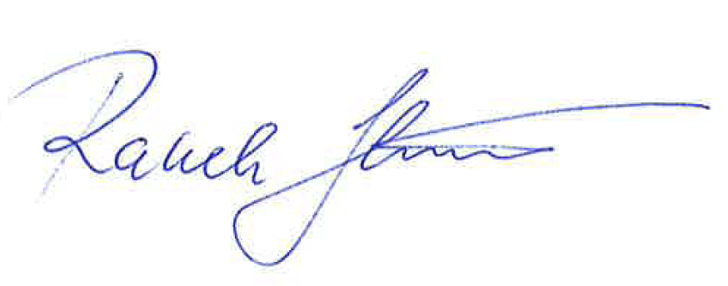
Radek Handlíř
CEO

